**Level 2 - INTERMEDIATE**

# Two Half Hitches

Also known by the names double half hitch and clove hitch around itself, this knot is an [overhand knot](http://www.101knots.com/overhand-knot.html) followed by a [half hitch](http://www.101knots.com/half-hitch.html). Always tie the Half Hitches in the same *“direction”.* If you start the first Half Hitch with the tail passing away from you above the rope, then do the same with the next. It can be tied around a ring, dock, post, tree, etc. It is commonly used in mooring and general utility. It is helpful in moving large objects, for example, logs.

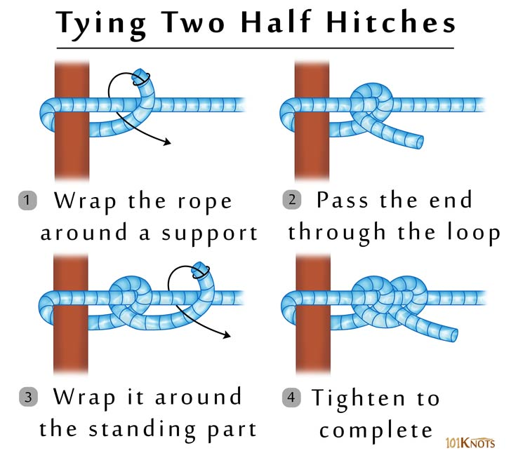

## Tips

1. Pry apart the 2 hitches with a bending motion to untie.

2. It is secure only when it is tied tightly around the support.

# Taut Line Hitch

It is a non-slipping, adjustable loop knot hitch based on the [rolling hitch](http://www.101knots.com/rolling-hitch.html). It is also known by the names adjustable hitch, tent-line hitch, tent hitch and rigger’s hitch. It slides freely but jams under load making line adjustments simple. You could reverse the direction of the [half hitch](http://www.101knots.com/half-hitch.html) made in step 3 of the below diagram to avoid twisting the knot

## Uses

1. Setting up hammocks or to secure tent guy lines.

2. Securing loads on vehicles.

# Whipping

The basic of whipping techniques, the common whipping, prevents a rope from fraying, that is, unraveling into thinner fibers.  It can also be used for securing objects together. It can be tied with twine or paracord. This technique is mentioned in The Ashley Book of Knots. It is also known as plain whipping, wolf whipping and ordinary whipping. It can be tied without using a needle or any tool.

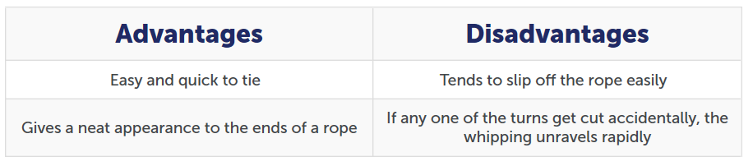

## Tips

1. The turns should cover a length equal to 1 1/2 to 2 1/2 times the rope diameter.

2. The wraps should be made tightly, keeping them close to each other.

3. While pulling on the standing end in step 5, take care to take the working end and bight only halfway underneath the whipping. If you pull it fully through by mistake, the knot comes undone.